

Lab Report

**Course Title:** Compiler Design and Construction Lab

**Course Code:** CSE-4104

**Submitted to:**

Dr. Md Manjur Ahmed Assistant Professor

Department of Computer Science and Engineering

University of Barishal

**Submitted by:**

Name: Protap Mistry Class Roll: 17CSE029 Exam Roll: CSE019/7

Department of Computer Science and Engineering

University of Barishal

**November 27, 2022**

**Index**

* **Chapter- 1: Introduction**
  1. **VI Editor Commands ……………………………………………………… 1**
  2. **Alternatives of VI Editor ………………………………………………...... 2**
  3. **Differences between Lex and Yacc ……………………………………….. 2**
* Chapter- 2: System Requirements Specification
  1. Hardware Requirements 4
  2. Software requirements 4
* Chapter- 3: Lab Works
  1. First Program 5
  2. First Homework 5
  3. Second Homework 6

3.4 Mini Project (My-Calculator) ……………………………………………..7

* Chapter- 4: Conclusion ……………………………………………….. 8
* References

# Chapter- 1: Introduction

A compiler is a computer program that helps in translating the computer code from one programming language into another language. Basically, it translates the program written in the source language to the machine language. The compiling process contains an essential translation operation and error detection.

In **Compiler Design and Construction Lab** we learnt about Lex, Yacc, VI editor and designed different types of lexical analyzer and parser. Lex is a program that generates lexical analyzer. It is used with Yacc parser generator. The lexical analyzer is a program that transforms an input stream into a sequence of tokens. It reads the input stream and produces the source code as output through implementing the lexical analyzer in the C program. Yacc is a computer program for the UNIX operating system developed by Stephen C. Johnson. It is a Look Ahead Left-to-Right Rightmost Derivation parser generator, generating a LALR parser based on a formal grammar, written in a notation similar to Backus–Naur Form. VI is a screen-oriented text editor originally created for the UNIX operating system. The portable subset of the behavior of VI and programs based on it, and the ex-editor language supported within these programs, is described by the Single UNIX Specification and POSIX.

This report represents basic commands about VI editor, alternatives of VI editor, difference between Lex and Yacc and some mini-project using Lex and Yacc that we learnt from our lab class(es).

## VI Editor Commands

* $ vi filename — Open or edit a file.
* $ vi -R filename - Opens an existing file in read only mode.
* i — Switch to Insert mode.
* Esc — Switch to Command mode.
* :w — Save and continue editing.
* :wq or ZZ — Save and quit/exit vi.
* :q! — Quit vi and do not save changes.
* j — Move down one line.
* k — Move up one line.
* 0 or | - Positions cursor at beginning of line.
* $ - Positions cursor at end of line.
* W - Positions cursor to the next word.
* B - Positions cursor to previous word.
* ( - Positions cursor to beginning of current sentence.
* ) - Positions cursor to beginning of next sentence.
* H - Move to top of screen.
* M - Move to middle of screen.
* L - Move to bottom of screen.
* r - Replace single character under the cursor with the next character typed.
* R - Replaces text from the cursor to right.
* s - Replaces single character under the cursor with any number of characters.
* S - Replaces entire line.

**1**

* X Uppercase - Deletes the character before the cursor location.
* x Lowercase - Deletes the character at the cursor location.
* Dw - Deletes from the current cursor location to the next word.
* d^ - Deletes from current cursor position to the beginning of the line.
* d$ - Deletes from current cursor position to the end of the line.
* Dd - Deletes the line the cursor is on.
* Yy - Copies the current line.
* p - Puts the copied text after the cursor.
* h — Move left one character.
* l — Move right one character.
* A — Append to the end of the line.
* I — Append text at the beginning of the current line.
* a — Append after the cursor’s current position.
* b — Go to the beginning of the word.
* e — Go to the end of the word.
* o — Open a new line under the current line.
* O — Open a new line above the current line.
* x — Delete a single character.
* dd — Delete an entire line.
* Xdd — Delete X number of lines.
* G — Go to the last line in a file.
* XG — Go to line X in a file.
* gg — Go to the first line in a file.
* :num — Display the current line’s line number.

## Alternatives of VI Editor

Traditional Ex - VI editor alternatives are mainly Text Editors but may also be Code Editors or IDEs. Some of them are Visual Studio Code, Notepad++, Atom, VSCodium, Kate, Gearny, GNU nano, gedit, etc. Among them:

1. **Visual Studio (VS) Code:**

* **Advantages:**
* [Extensible by Plugins/Extensions](https://alternativeto.net/feature/extensible/)
* [Lightweight](https://alternativeto.net/feature/lightweight/)
* [Auto-completion](https://alternativeto.net/feature/autocompletion/)
* [Syntax Highlighting](https://alternativeto.net/feature/syntax-highlighting/)
* [Git Support](https://alternativeto.net/feature/git/)
* [Support for Themes](https://alternativeto.net/feature/themeable/)
* [Dark Mode](https://alternativeto.net/feature/night-mode/)
* [Support for Mark-Down](https://alternativeto.net/feature/markdown-support/)
* [No registration required](https://alternativeto.net/feature/no-registration/)

**2**

* **Disadvantages:**
* Some settings are not very easy to toggle.
* For some extensions also the settings are not as easy as they require configuration file changes which might be difficult for beginner users.
* Sometimes the name 'Visual Studio Code' confuses people with Microsoft's IDE 'Microsoft Visual Studio'.

1. **Notepad++:**

* **Advantages:**
* [Lightweight](https://alternativeto.net/feature/lightweight/)
* [Code Formatting](https://alternativeto.net/feature/code-formatting/)
* [Portable](https://alternativeto.net/feature/portable/)
* [Extensible by Plugins/Extensions](https://alternativeto.net/feature/extensible/)
* [Auto-completion](https://alternativeto.net/feature/autocompletion/)
* [Syntax Highlighting](https://alternativeto.net/feature/syntax-highlighting/)
* [Live Preview](https://alternativeto.net/feature/live-preview/)
* **Disadvantages:**
* It is difficult for newbies who make mistakes often as there are not many external aids when writing code.
* The interface is not convincing, the code that is written often is not very visible and very confusing at first sight.
* The most disadvantage of Notepad++ is that it is not multiplatform.

## Differences between Lex and Yacc

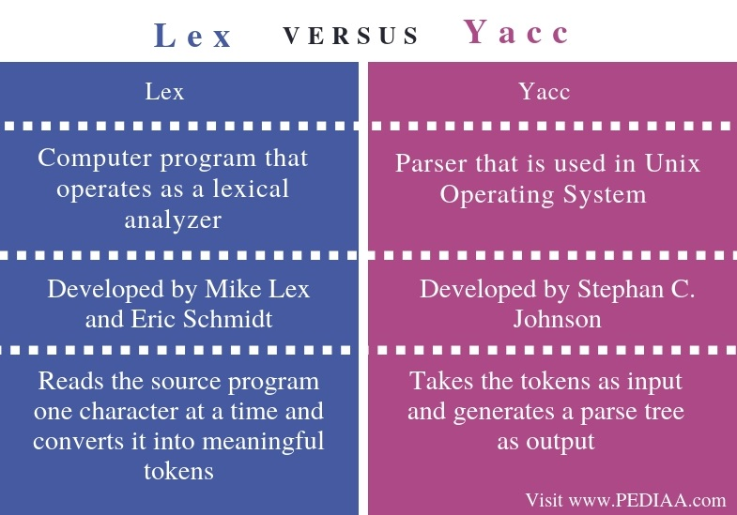

**3**

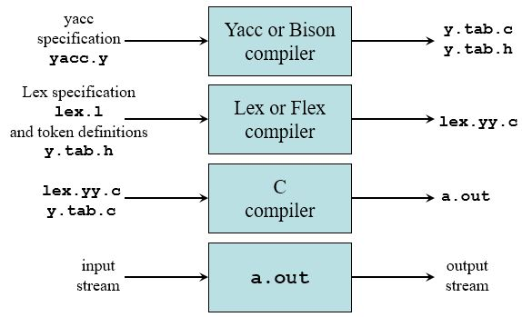

**Fig. Combination with Lex and Yacc**

# Chapter- 2: System Requirements Specification

Software requirements for a system are the description of what the system should do, the service or services that it provides and the constraints on its operation.

## Hardware Requirements

Minimum hardware requirements are:

* + - Processors: 1.0 GHz or above
    - RAM: 4GB or above
    - Hard Disk: 40GB or above
    - Keyboard: QWERTY keyboard
    - Mouse: 2 or 3 button mice

## 

## Software Requirements

Minimum software requirements are:

* + - Operating System: Linux, Ubuntu, Windows (Virtual Box) etc.
    - IDE Used: VI
    - Library Used: C
    - Bit: X64 also run on X86
    - Driver: Mouse Driver, Graphics Driver
    - Compiler Language: Lex and Yacc.

**4**

# Chapter- 3: Lab Works

Lab works combines experience and innovation to provide comprehensive and tailored solutions for your LIMS needs by using the latest technologies and laboratory best practices to provide an efficient user experience (UX) that is supported by automation and real time data analytics.

**3.1 First Program**

This is the very basic and beginner level work of Lex where used VI editor.

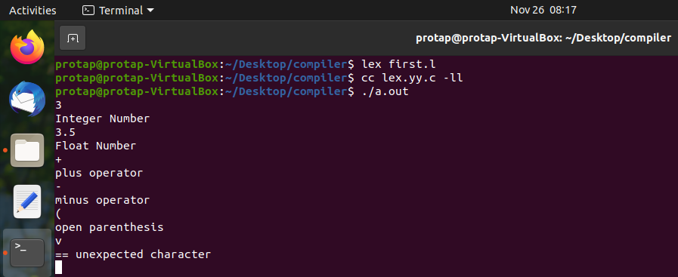

**Fig. I/O of the first program using Lex**

**3.2 First Homework**

This is also basic level work of Lex where used VI editor for showing almost all the operators with parenthesis.

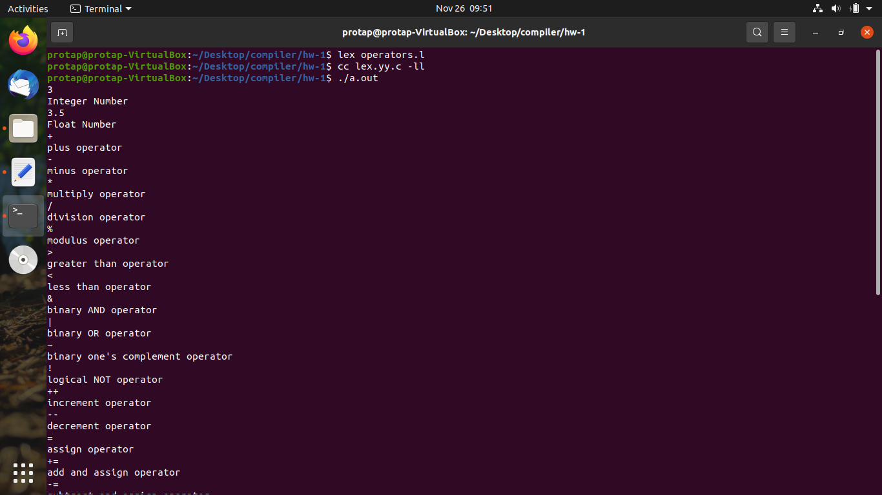

**Fig. I/O of the first homework using Lex**

**5**

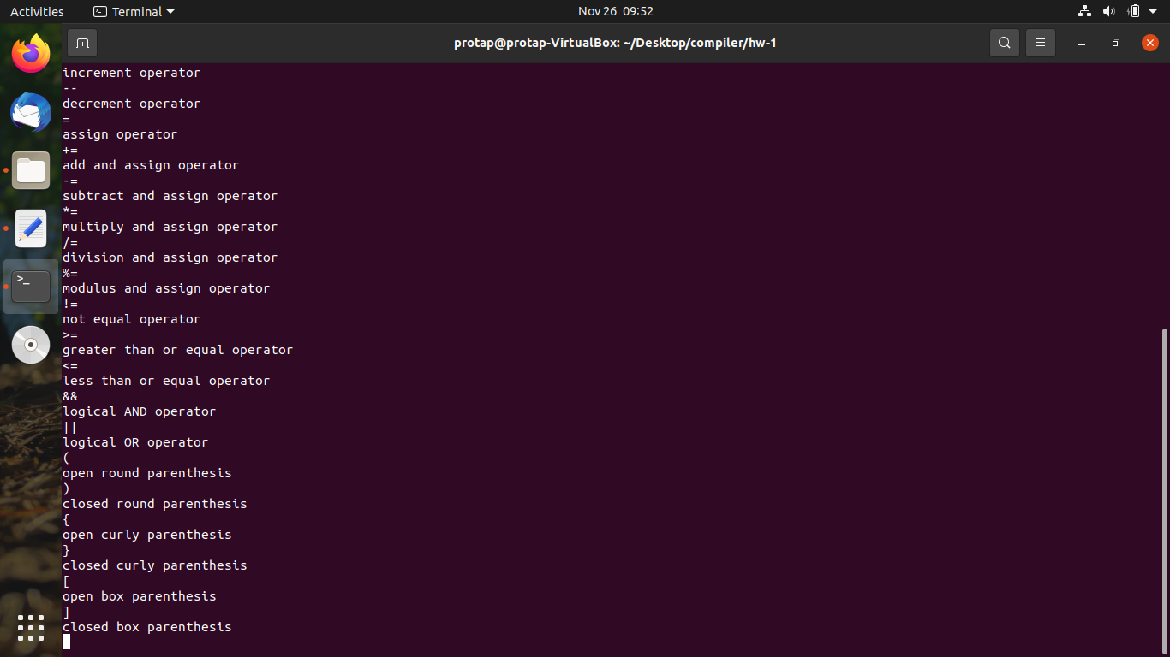

**Fig. I/O of the first homework using Lex**

**3.3 Second Homework**

This is somewhat advance level work of Lex where used VI editor for showing dummy data retrieving (Scanner) from the **config** file with the help of C ad its header file.

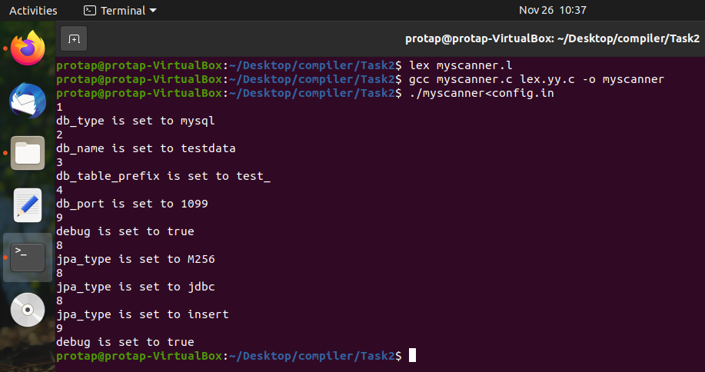

**Fig. Output of the second homework using Lex**

**6**

**3.4 Mini Project (My-Calculator)**

It’s a mini project of Lex and Yacc where used VI editor for showing some normal mathematical calculation like addition, subtraction, division, multiplication, modulus, average, percentage, etc by the help of C and Yacc header file.

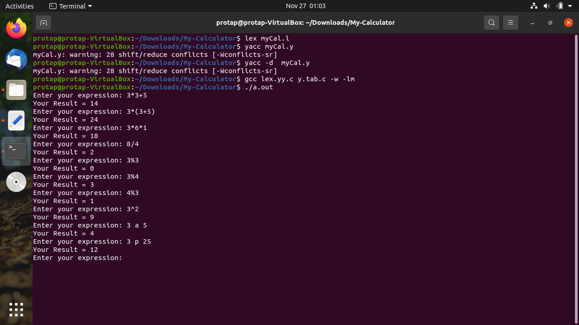

**Fig. I/O of the mini project using Lex and Yacc**

**7**

# Chapter- 4: Conclusion

Compiler Design and Construction is really an important course in the field of Computer Science because from its lab we learnt a lot of advance thing like Lex, Yacc, VI editor with commands, Scanner, Parser. Some basic and advanced level task also done using Lex and Yacc in this course that will help us a lot in future.

# References

1. <https://repository.unikom.ac.id/50738/1/Compilers%20%20Principles,%20Techniques,%20and%20Tools%20(2006).pdf>
2. <https://www.tutorialspoint.com/what-is-lex>

[3]https://www.javatpoint.com/yacc

[4]<https://www.geeksforgeeks.org/vi-editor-unix/>

[5] https://alternativeto.net/software/traditional-ex---vi-editor/

[6][https://pediaa.com/what-is-the-difference-between-lex-and-yacc/](https://pediaa.com/what-is-the-difference-between-lex-and-yacc/%0c)